Methodology:
The proposed system is a hybrid model of combining Autoencoder (AE) and Vision Transformer (ViT) with Explainable AI (XAI) to predict the type and region of the presence of brain tumor. This section elaborates about the methods used to train the proposed Deep Learning (DL) model.
Dataset Collection:
The data of this research was taken out of the publicly available Brain Tumor MRI Dataset on Kaggle. It is based on 10,288 magnetic resonance imaging (MRI) scans of brain tumors whose classification was done into four groups: Glioma, Meningioma, Pituitary tumor, and No tumor. The images are grouped by tumor type and anatomical orientation, and are annotated by experts in order to be corrected. This heterogeneous and equalized data is a good basis to train and assess deep learning models. The data was separated into two subsets; training and testing with 80:20 ratio in a disproportional class distribution.
Data Preprocessing:
The Data preprocessing stage involves resizing of all MRI brain input images to a uniform size, which is compatible with the Vision Transformer (ViT) input. The pixel intensity values are then normalized in order to normalize the input distribution. In order to make the model more universal, it is possible to use augmentation techniques like rotation, flipping.
Auto encoder:
The autoencoder component of the proposed architecture contains an unsupervised feature extractor, which converts every preprocessed MRI image into a small latent code. The architecture will include an encoder, which employs a sequence of convolutional and pooling layers to extract image features of higher level and dropping the dimensionality. Afterward, a bottleneck layer is used, where the most significant information is captured to be used in downstream tasks. The decoder is the reflection of the encoder, based on upsampling and transposed convolutional layers to rebuild the original picture in its presented compressed version. Minimizing the mean squared error (MSE) between the output and input images is used to train the autoencoder:
- Encoder-Decoder mapping:
$$z=f_{θ}​\left(x\right),\hat{x}=g_{∅}\left(z\right)$$
where x is the input image and $\hat{x}$ is the reconstructed output. By encouraging accurate reconstruction, the autoencoder learns to retain key structural and pathological details relevant to brain tumor detection. The resulting encoder latent codes are then used as input features to the Vision Transformer (ViT) to maintain the most informative elements of every MRI scan and utilize it to classify that element. This method increases the robustness, reduces the dimensions, and assists the overall pipeline to concentrate on medically significant visual patterns against the complicated MRI data. The Adam optimizer is used to perform training and the early stopping criteria help to avoid overfitting of the model and provide the stable convergence.
Vision Transformer Architecture:
The pre-processed images are divided into constant sized patches. The patches are flattened to produce patch embeddings which are projected into an embedding (feature) space. Positional encodings are also included with the patch embeddings to maintain the spatial information that otherwise would be missed to the transformer model, and they are flattened by Sine and Cosine functions.
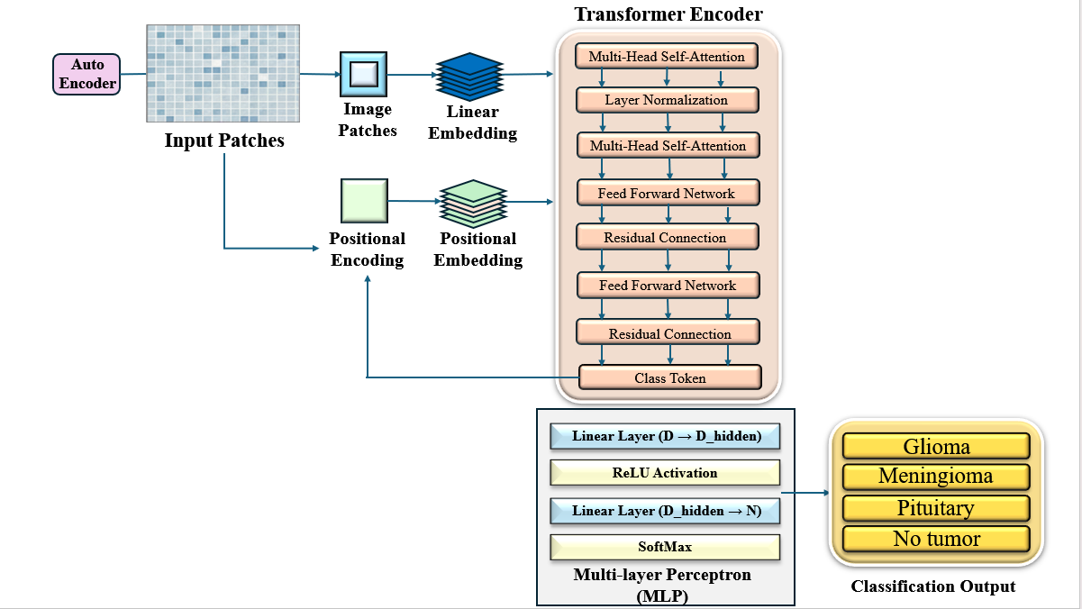
- Patch Embedding:

For image, $x∈R^{H×W×C}$ ,
Divide into patches of size P × P:
$$x →\left\{x_{p }^{1}, x_{p}^{2 }, ....., x_{p}^{N}\right\}, N = \frac{HW}{P^{2}}$$
Each patch flattened and projected:
$$z_{0}^{i} = x_{p}^{i}W_{e}+ E_{pos}^{i}$$
- Transformer Encoder Block (per layer $l$):
$z^{(l)}´$ = $z^{(l-1)}+MSA({LN(z}^{(l-1)}))$
$z^{(l)}$ = $z^{(l)}´+MLP({LN(z}^{(l)´}))$
Auto encoder + vision Transformer Model:
Besides the typical architecture of Vision Transformer, this project uses an Autoencoder to extract unsupervised feature. Autoencoder encodes MRI images as input z=fθ​x to latent space representations z.
- Autoencoder Encoding:
z=fθx
where z can be defined as compression in latent space and this component of compressing image data removes the noise contained in the image data and forms the significant image characteristics.
- Reconstruction Loss:
$$L_{AE} ​\left(x,\hat{x}\right)=\frac{1}{N}\sum_{i=1}^{N}{∥}x_{i}-{\hat{x}}_{i}∥^{2}$$
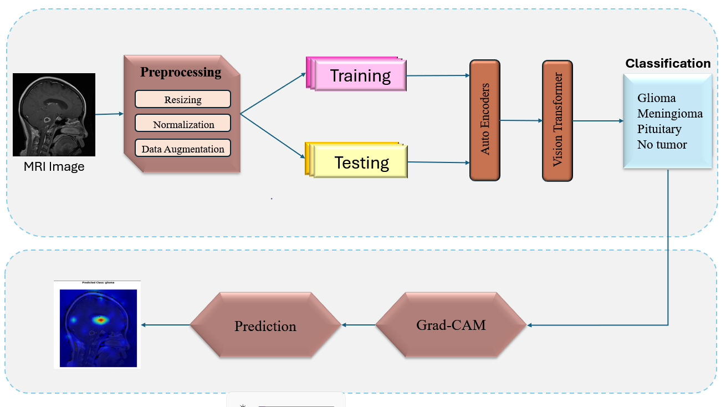
The encoded latent features are divided into patches and instead of patching raw images they are sent to the patch embedding and positional encoding steps of the Vision Transformer. The hybrid method aids in the feature learning of the Autoencoder and the effective sequence modeling of ViT.
These encoded patch embeddings are then processed by the transformer encoder through several layers of multi-head self-attention network and feed-forward network with the help of layer normalization and residual connection.
- Feed Latent Features into ViT:
$$z_{p}^{i}=z_{p}^{i}W_{e}+E_{pos}^{i}$$
- Transformer Encoding:
$$h^{(l)}=TransformerBlock\left(h^{\left(l-1\right)}\right), l=1,...,L$$
Where $h^{\left(0\right)}=\left\{{\tilde{z}}_{p}^{ⅈ}\right\}$
A combined loss is reduced through joint training:
Ltotal= λclsLCEy,y+ λaeLAEx,x
LCE cross-entropy classification loss, LAE reconstruction loss, λcls, λae and are hyperparameters used to weight the two losses.
This method enhances the ability to learn features of brain tumor that are used in classifying the disease, as well as the local reconstruction information of the image that is used to strengthen the model and precision.
Layers processing of the embedding patches is done by the multi-head self-attention mechanisms and feed-forward neural networks in the transformer encoder. The termination of both layers of multi-head self-attention mechanisms and feed-forward neural networks is done by layer normalization and residual connections to every process. The order of the embedded patches is to first feed special classification token (CLS) into the multi-layer perceptron (MLP) class classification head to generate the probability of the tumor type class.
- Classification Head:
$$\hat{y} = Softmax\left(W_{cls}z_{[CLS]}^{(L)}+ b_{cls}\right)$$
Training and Testing Workflow:
The model is trained using the labeled MRI images and distinguishes among the four types of tumors in the brain namely Glioma, Meningioma, Pituitary tumor and No tumor. The data is split into the training and testing data. The goal of the training is a composite loss which involves cross-entropy classification loss and recreating loss with Autoencoder with suitable weighting parameters. The joint loss is minimized with the help of an optimizer like Adam. During the test stage, the trained model estimates the presence and the type of tumor in invisible MRI images using the representations of Autoencoder and Vision transformer.
- Cross-Entropy Loss (classification):
$$L_{CE} ​\left(y,\hat{y}\right)=-\sum_{c=1}^{C}{y_{c}\log{({\hat{y}}_{c})}}$$
- If combining Autoencoder + Classification:
$$L_{total}= λ_{cls}L_{CE}+ λ_{ae}L_{AE}$$
Classification Layer:
The results of the ViT encoder are fed into the dense layers that subsequently classify the final results among the four target classes. This layer renders the learnt features more specific to the reliable and accurate predictions.
Explainability with Grad-CAM:
Gradient-weighted Class Activation Mapping (Grad-CAM) is used to give interpretability and visualisation of the areas of the MRI scan that are informative to the decision made by the model. Grad-CAM also generates a heatmap superimposed on the MRI scan indicating tumour areas that the model predicts, this will help to validate as well as ensure that the model is operating correctly, the predictions made by the model.
Grad-CAM generates a heatmap on top of the MRI scan of the tumor areas that the model predicts, which is useful in assessing a clinical validation and trustworthiness of the model.
- Importance weights for feature map k:
$$α_{k}^{c}=\frac{1}{Z}\sum_{i}{\sum_{j}{\frac{{∂y}^{c}}{{∂A}_{ⅈj}^{k}}}}$$
- Grad-CAM Heatmap:
$$L_{GradCAM}^{c}= ReLU\left(\sum_{k}{∝_{k}^{c}A^{k}}\right)$$
This pipeline of methodology offers a headbang of sophisticated transformer-based modelling, preprocessing and explainability to secure excellent brain tumour detection on the basis of MRI images.
Evaluation Metrics:
To validate the performance of the proposed Autoencoder–Vision Transformer model, several evaluation metrics are employed. These metrics provide a quantitative assessment of classification quality and robustness across different tumor categories.
1. Accuracy
Accuracy gives the overall percentage of correctly classified MRI scans, including both tumor and non-tumor cases:
- Accuracy:
$$Accuracy = \frac{TP+TN}{TP+TN+FP+FN}$$

2. Precision
Precision shows how reliable the model’s positive predictions are. It is the proportion of predicted tumor cases that are actually correct:
- Precision:
$$Precision = \frac{TP}{TP+FP}$$
High precision means the model makes very few false alarms.

3. Recall (Sensitivity)
Recall measures how well the model detects actual tumor cases. It is the fraction of tumors correctly identified out of all true tumors:
- Recall:
$$Recall = \frac{TP}{TP+FN}$$
High recall means the model rarely misses tumors.

4. Specificity
Specificity complements Recall. It measures how well the model identifies non-tumor cases:
- Specificity:
$$Specificity = \frac{TN}{TN+FP}$$
​ High specificity means the model rarely confuses healthy scans for tumor cases.

5. F1-Score
The F1-score balances Precision and Recall by taking their harmonic mean:
- F1-Score:
$$Fl =2·\frac{Precision·Recall }{Precision + Recall}$$
​ This metric is especially useful when the dataset is imbalanced, because it penalizes both false negatives and false positives.

6. Geometric Mean (G-Mean)
The G-Mean evaluates the balance between Recall and Specificity:
- G-Mean:
$$G - mⅇan= \sqrt{Sensitivity×Specificity}= \sqrt{\frac{TP}{TP+FN}×\frac{TN}{TN+FP}}$$
A high G-Mean indicates that the model is performing well on both tumor and non-tumor cases, avoiding bias toward a single class.

